**Phase 2:**

Arms: Placebo vs CILO/FIR,

N:  150/arm but also run 200, 250, 300/arm

Outcomes:

Fibrosis improvement without worsening in NASH;

binary outcome measured at week 72

Placebo rate: 12%

Placebo Adjusted Treatment Effect 0%, 10%, 15%, 20%, 25%, 30%

🡪 Treatment Rate: 12%, 22%, 27%, 32%, 37%, 42%

                Analysis/Decision: Based on Go/No Go framework using

(LRV, TV) = (10%, 15%), (10%, 20%), (15%, 20%), (15%, 25%)

Values for the CI: (5%, 80%), (5%, 90%), (10%, 80%), (10%, 90%), (20%, 80%), (20%, 90%)

At current stage, can try both options below.

Option 1

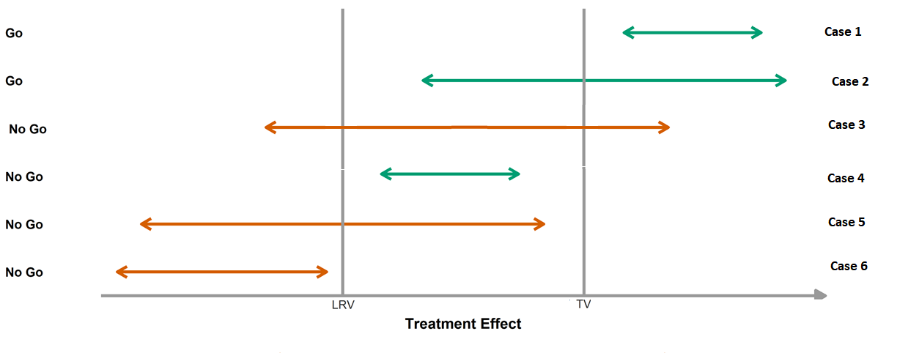

Option 2 - Note: Frewer with Consider -> No Go

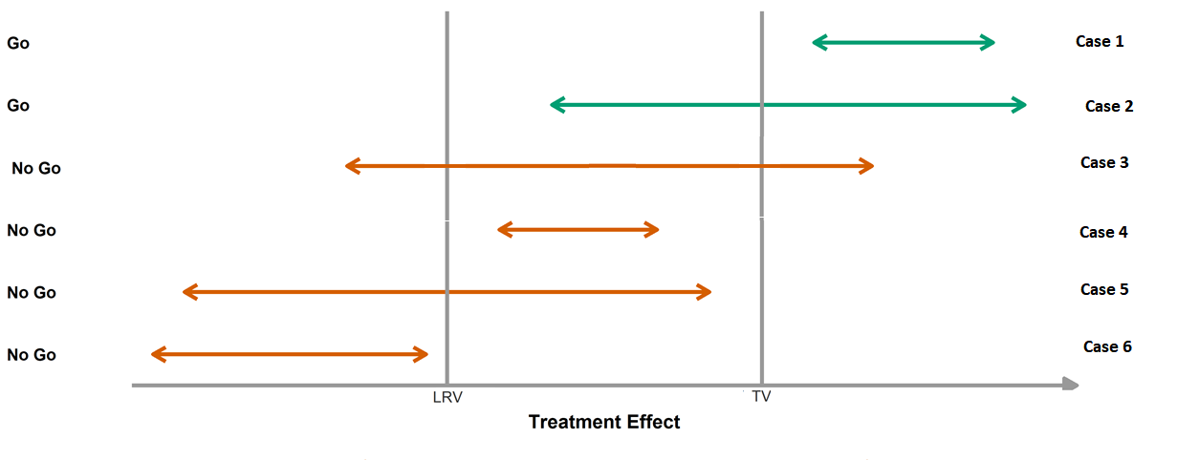

In addition to meeting go criteria, also need to satisfy that the response rate in the active arm ≥ 20%

Note: The standard analysis is Fisher exact

See attached monthly accrual for the following studies:

* Ph2 - SIM 0106 and ATLAS 4378: can take average
* Ph3 - STELLAR 1943 and 1944: can take sum as the two studies were conducted at the same time. Can also be projected to a faster accrual rate proportionally.

Expected output from phase 2 simulation: Similar output to the next graph, various sample size, decision boundaries ect.

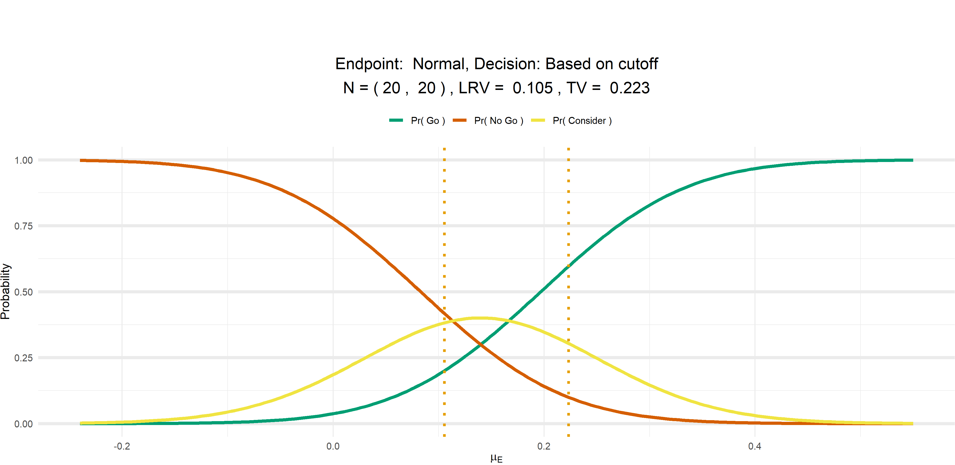

**Phase 3:**

Arms: Placebo vs CILO/FIR,

N:  1250/arm

Outcomes:

Fibrosis improvement without worsening in NASH;

binary outcome measured at week 72

Placebo rate: 12%

Placebo Adjusted Treatment Effect 0% 10%, 15%, 20%, 25%, 30%

🡪 Treatment Rate: 12%, 22%, 27%, 32%, 37%, 42

                Analysis/Decision

The standard analysis is Fisher exact run with 750/arm patients have 72 week data for subpartH

Option 1: 0.01 (using multiple testing procedure if this is significant then we can use 0.05 for Clinical outcome and if not then use 0.04 for clinical

Option 2: 0.0002 (using multiple testing procedure if this is significant then we can use 0.001 for Clinical outcome and if not then use 0.0008 for clinical

**Include patients from Phase 2:** Allow for options both with and without

Drop out rate: 20% drop at 5 years in all arms; use exponential distribution with 20% at 5 years.

Event or dropout < 72 means treatment failure

May also try Event or dropout < 36 means treatment failure (due to analysis window)

See attached monthly accrual table.

Sample Size Reestimation: More subjects may be enrolled to ph4 depending on the clinical outcome data at end of Ph3. To be detailed out will not be considered for now.

**Phase 4 (continued Phase 3):**

Continued follow-up of phase 3 data and the primary analysis is based on clinical events.

Since this phase depends on the clinical event and is FU data from Phase 3 and possible Phase 2 then we need to simulate data for both the binary outcome and the time-to-event data.

In order to build this correlation an approach that has been used in the past is to change the event rate based on if the patient is a responder or not:

For example:

If the patient is

Responder -> 5 year event rate is 5%, 8%,10%

Non-Responder -> 5 year event rate is 30%, 33% and 36% (12% response rate + 5% and 33% event rate for responder and non-responder, respectively, gives an approximate 30% event rate in placebo)

The time-to-event can be assumed to be Exponential

See attached spreadsheet for required number of events for 1:1 randomization.